Techdome Assignment

* First, I went to the AWS console and created an instance for an Ubuntu machine with a T2 medium size, featuring 2 CPUs and 4 GB of RAM.

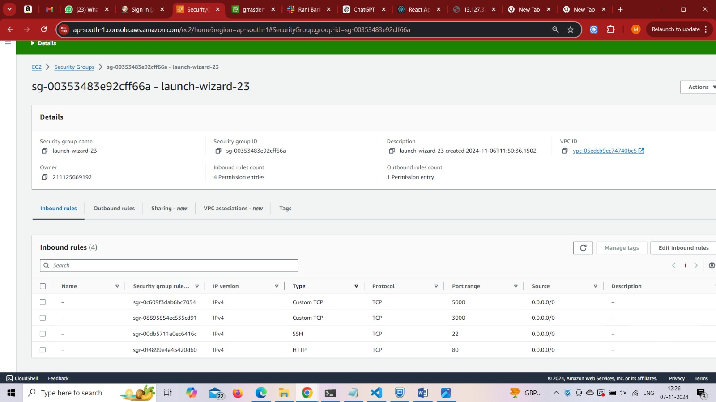

* After that, I installed Docker, Docker Compose, and Git, along with all necessary dependencies.

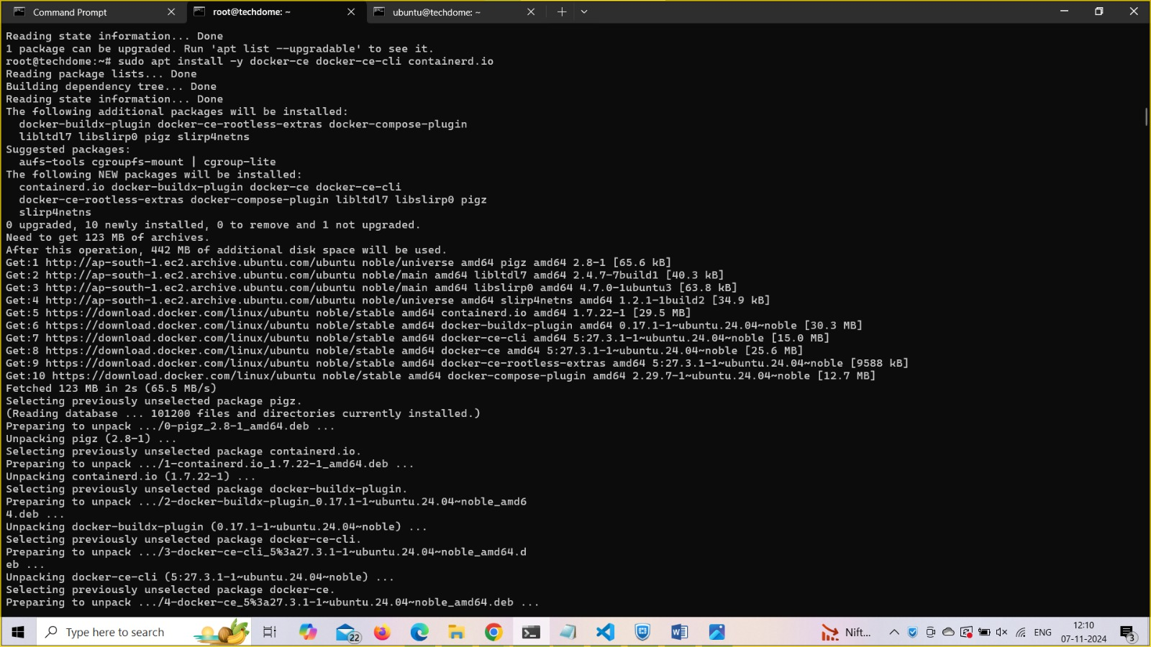

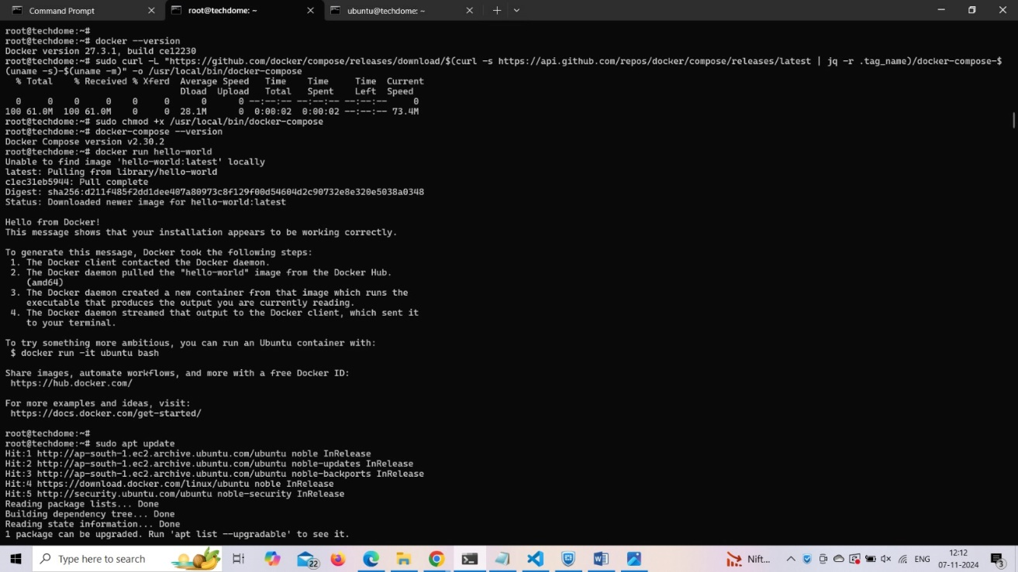

* After that, I cloned the repository provided by you onto my machine.
* Next, I created a docker-compose.yml file to set up interconnected services for the frontend, backend, and database.

* Now, I went to the backend’s root directory and created Dockerfiles for both the backend and frontend.

* **Build and Start Containers**: Run commands in the root folder where docker-compose.yml is located (docker-compose up –build)

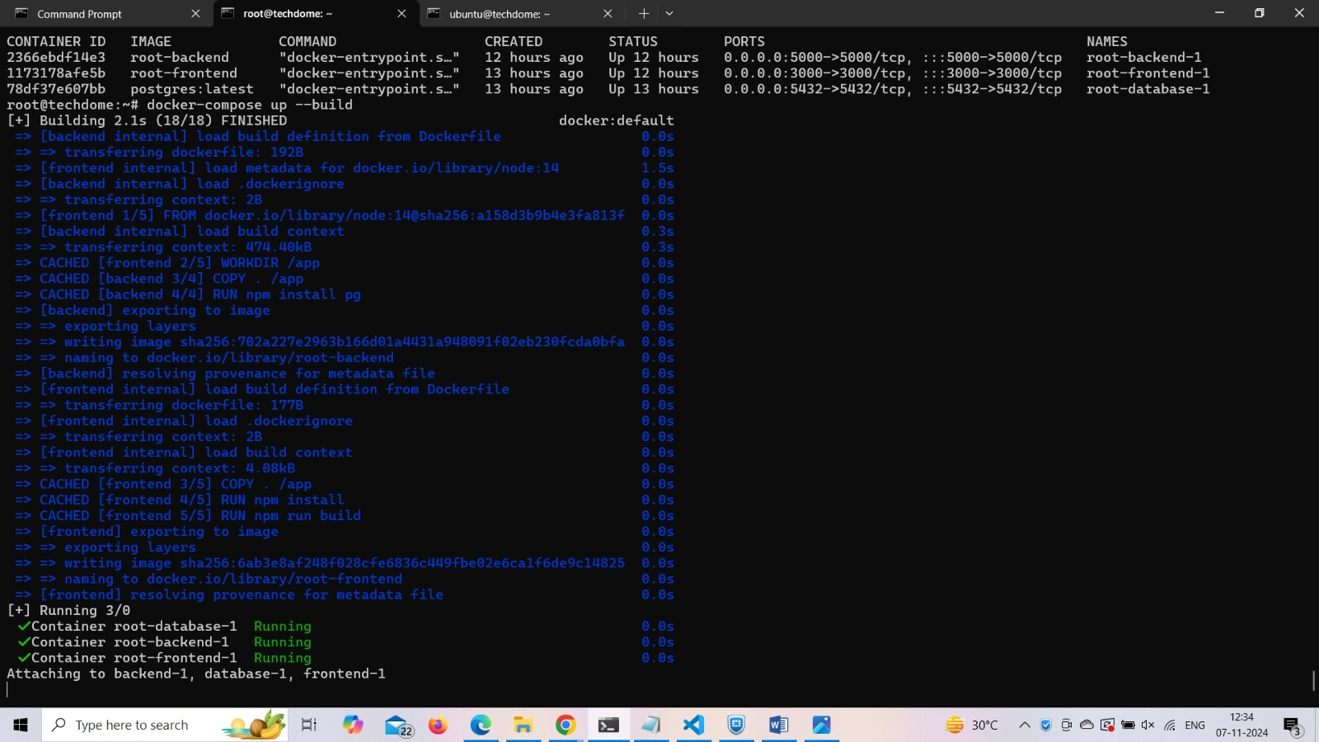

* This command will build the images and start all services, making the frontend available at

Access the frontend at <http://13.127.37.238:3000> to interact with the application

Access the backend at <http://13.127.37.238:5000> to interact with the application

